1. WEBSITE DETAILS
Title of the Website:
Productivity Tool
Purpose of the Website:
SUMN is a productivity tool designed using HTML and CSS. It provides a visually structured welcome page and interface that helps users organize tasks and view productivity insights.
Target Users:
- Students
- Beginners in Web Development
- Educational Institutions
Tools Used:
- HTML5, CSS3
- Text Editor (VS Code)
- Web Browser (Chrome / Edge / Firefox)
Key Features:
- Semantic HTML structure
- SEO-friendly meta tags
- Accessible content layout
- Embedded audio and video with controls and captions

2. TAG DEFINITIONS USED IN THE WEBPAGE

2.1 Basic Structure Tags
Tag | Definition
<html> | Defines the root element of the HTML document
<head> | Contains metadata, stylesheet links, and script references
<meta> | Specifies character encoding and responsive viewport settings
<title> | Sets the title of the webpage displayed on the browser tab
<link> | Links external CSS stylesheet to the webpage
<script> | Adds JavaScript functionality and interactivity
<body> | Contains all visible content of the webpage

2.2 Semantic Tags

Tag | Definition
<aside> | Defines the sidebar section used for navigation
<nav> | Contains navigation links of the productivity tool
<main> | Represents the main content area of the webpage
<section> | Groups related content such as welcome page sections

2.3 Multimedia/Graphics Tags
Tag | Definition
<svg> | Used to create scalable vector graphics for charts
<polyline> | Draws the productivity line chart inside SVG
<circle> | Represents data points on the productivity graph

2.4 CSS PROPERTIES USED

CSS Property | Definition
display | Defines the layout behavior of elements such as flex, grid, or block
flex | Used to create flexible layouts for sidebar and content alignment
grid | Arranges content in rows and columns
background | Sets background color and gradient styles
color | Defines the text color
font-family | Specifies the font style used on the webpage
padding | Adds space inside elements
margin | Adds space outside elements
border-radius | Rounds the corners of elements
box-shadow | Adds shadow effects to cards and buttons
transition | Applies smooth hover and state-change effects
animation | Creates motion and visual effects
@media | Applies responsive design for different screen sizes
:hover | Defines styles when the mouse pointer is over an element
:root
  Defines CSS variables for global theme colors

3. SCREENSHOTS

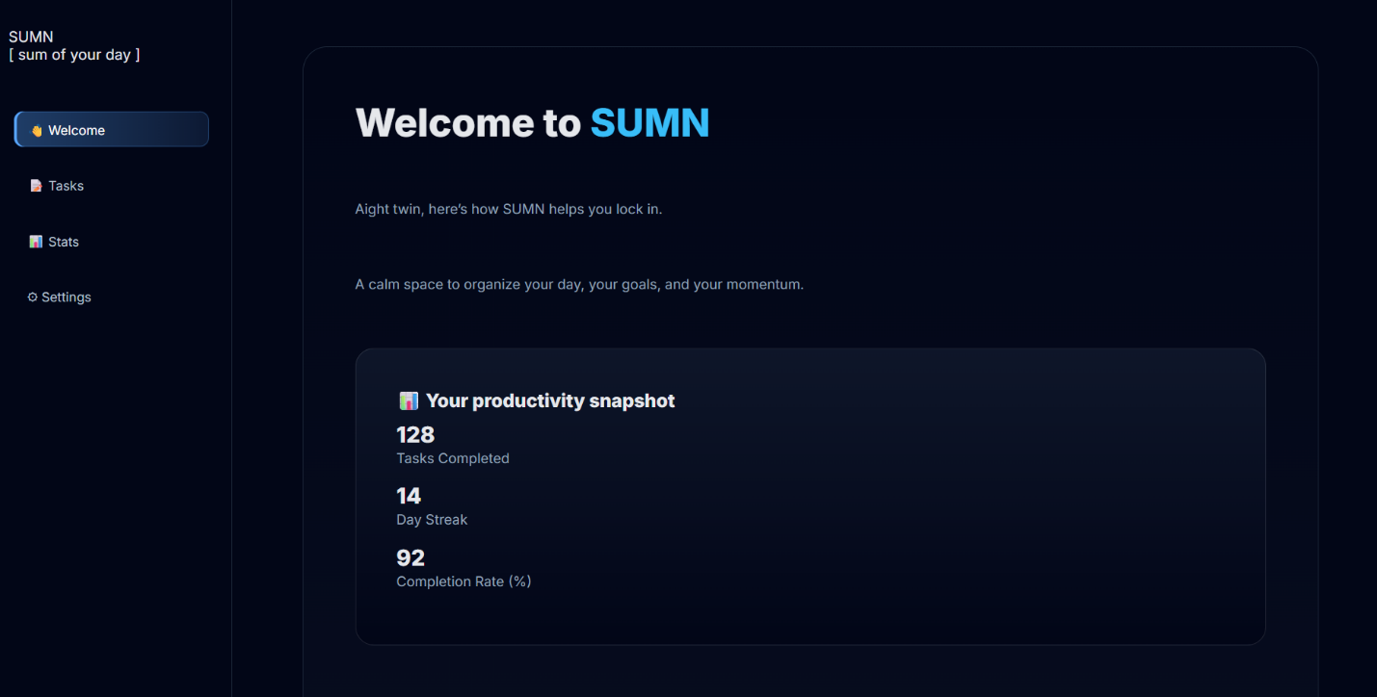
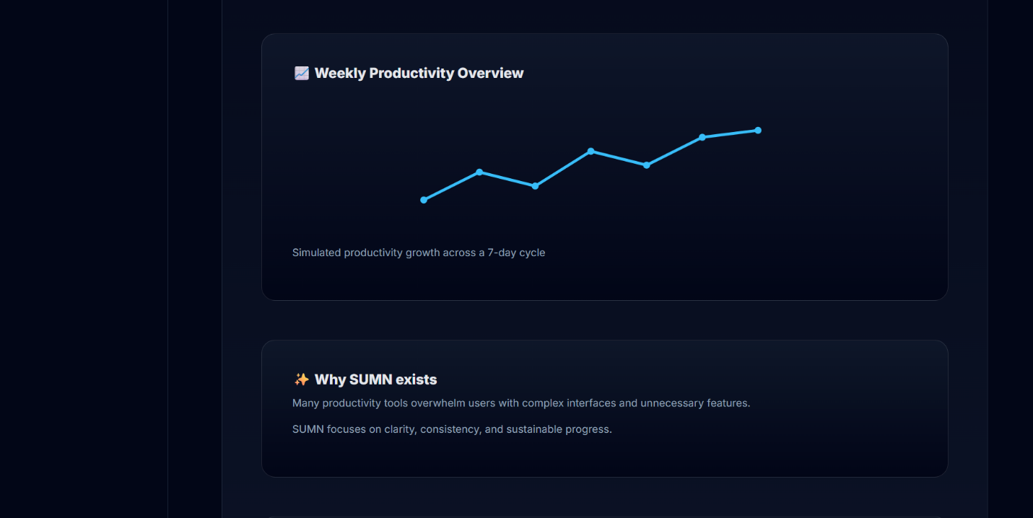

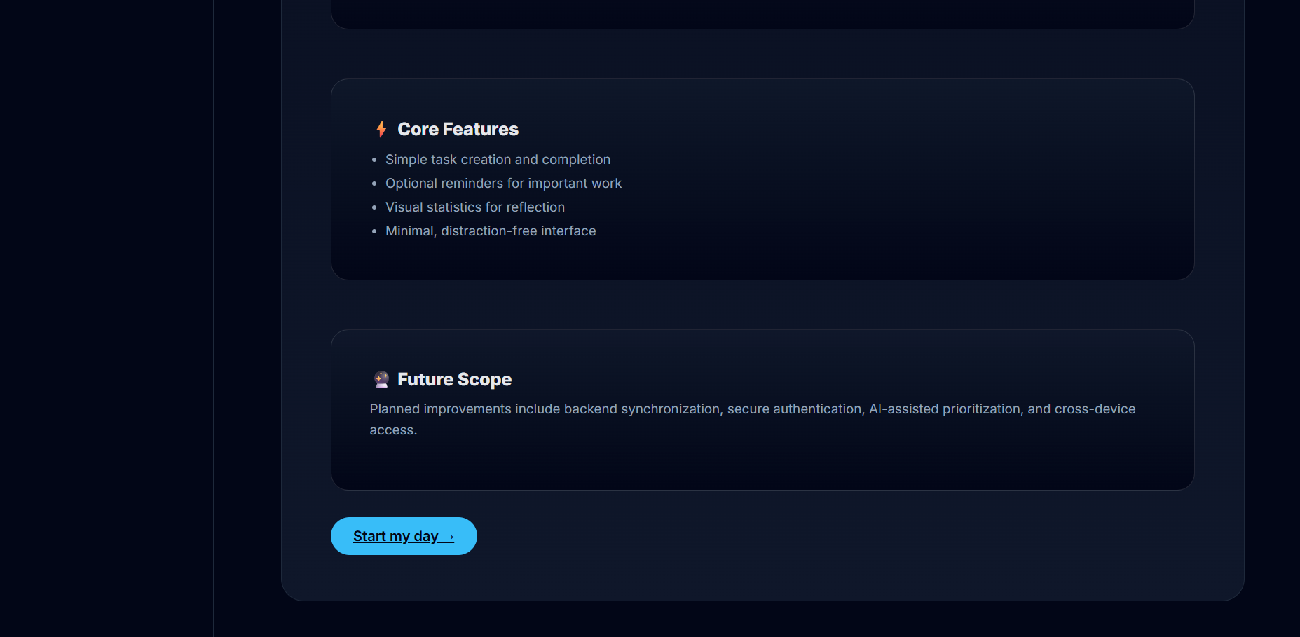

4. DECLARATION
I hereby declare that this practical work entitled
“Design and Development of a Semantic and Multimedia Webpage Using HTML5”
is my original work carried out by me. This work has not been copied from any source and has not been submitted earlier for any examination.
Name of Student: Yash Tambade
Roll Number : 150096725173
Date: 09-02-2026

5. FUTURE SCOPE
The current website is developed using only HTML5. The future enhancements that can be implemented are:
- Applying CSS for improved visual design and layout
- Adding interactivity using JavaScript
- Making the website fully responsive for all devices
- Hosting the website on a live server
- Adding forms and backend integration
- Enhancing accessibility using ARIA attributes

